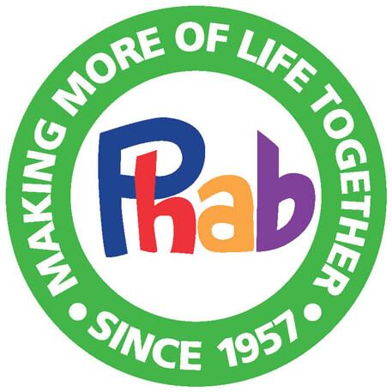
Phab – London Marathon 2022
Press Release

Phab has existed since 1957 when a young disabled person, Terry Rolfe, attended a conference of national youth clubs asked for “opportunity for disabled people, not pity”. This comment led to the creation of Phab and 65 years of leading the way of embedding inclusion.
Whether in the national collection of over 120 local Phab Clubs, affiliated to the central charity Phab Ltd, where disabled and non-disabled people of all ages come together in social environments, the projects, that are inclusive residential experiences with physical , educational, and social activities in fully accessible venues run by Phab Ltd, or special events, such as the recent flying days where members of our Phab Clubs had the chance to fly a light aeroplane, Phab is about bringing everyone together to have fun in safe social locations. Another area of special interest is supporting young carers, aged between 11 and 18, by running breaks for them to have time away from caring.
One of Phab’s key funding streams comes from the amazing people who take part in the TCS London Marathon. Phab would like the thank the London Marathon for it’s ongoing support and each and every runner raising money to support Phab’s work around inclusion. Phab would like to introduce you to ………………(fill in your name here) who is running for us from your area.
(Put your story about getting ready for the marathon and why you are running for Phab here and your contact details for interview.)
For more information on Phab visit our website www.phab.org.uk or contact Mik Scarlet – mik.scarlet@phab.org.uk or George Whittingham – George - george.whittingham@phab.org.uk
Phab’s Challenge Events Manager is Janine Williams - janine@phabkids.co.uk – who can give you all the information on this year’s runners and Phab’s connections to the London Marathon.

