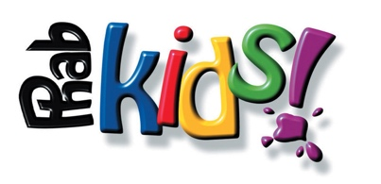
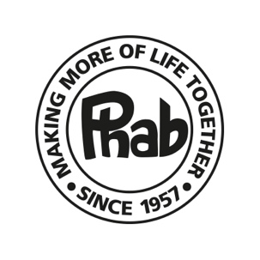
Charity No.283931
Terms and Conditions
London Landmarks Half Marathon – Sunday 3rd April 2022

• When submitting the on-line application, you agree to raise the minimum pledge of £400.00 excluding Gift Aid.

• If your application is accepted by Phab you will agree to raise £200.00 of your pledge by Friday 25th of March 2022. Failure to do this, could result in Phab withdrawing you from the event. The remainder of the pledge is due by 3rd July 2022.

• If this event is cancelled by the organisers, the sponsorship you have raised will be treated as a donation to Phab.

• If you are an existing runner, we will require you to open a new fundraising page, and not add to any existing pages, as existing sponsorship cannot be used.

• In the event of a shortfall in your fundraising, you agree to make up that shortfall personally.

• The minimum pledge applies once you are accepted to take part in the event by Phab, using one of Phab’s guaranteed entries.

• Funds raised off-line (not via Justgiving or Virgin Money Giving) in The London Landmarks Half Marathon must be sent personally to Phab and not given to a third party to send on to Phab, unless previously agreed.

• We require you to send in off-line sponsorship as it is raised, by cheque or BACS. Any remaining sponsorship must be received by Phab no later than 3rd July 2022.

• In no circumstances can you transfer your entry to another person.

• Phab reserves the right to withdraw an entrant at any time.

• This place is to be used to raise money for Phab and Phabkids. It cannot be shared with another Charity.
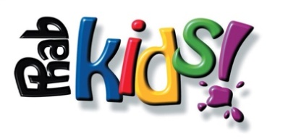
Charity No.283931

On-line Fundraising for Runners 2022

Create your on-line sponsorship page by visiting:
http://www.justgiving.com/phab/raisemoney
Then follow the simple instructions to create and personalise your page.

Once you have created your page, email your page details to family, friends, colleagues and other contacts for them to donate quickly and easily on-line with a credit or debit card.

On-line donations from UK taxpayers will automatically benefit from the bonus of Gift Aid (currently 25%).

The Gift Aid payment CANNOT be considered as part of your minimum pledge amount.

Funds raised via Justgiving come directly through to Phab and we are updated weekly on your level of on-line sponsorship.

JW 01/09/2021

