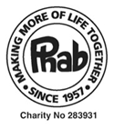
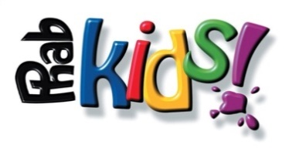

Phab - Terms and Conditions 2021
Virtual Virgin Money London Marathon Guaranteed Entry

When submitting your on-line application, you agree to raise the minimum of £400.00 excluding Gift Aid. Online fundraising pages MUST be set up within 4 weeks of accepting this place.

- In the event of there being a shortfall in your fundraising, you agree to make up that shortfall personally.

- The minimum pledge applies once you are accepted to run by Phab having been allocated a guaranteed entry with Phab.

- The guaranteed entry is given on the understanding that you raise sponsorship exclusively for Phab. This cannot be shared to raise funds for any other Charity.

- Funds raised off-line by each Phab runner (not via JustGiving or Virgin Money Giving) must be sent personally to Phab and not given to a third party to send on to Phab, unless previously agreed. These funds need to be sent in after every event.

- We require you to send in offline sponsorship as it is raised, by cheque or BACS, and any remaining sponsorship must be received by Phab no later than 3rd January 2022.

- Under no circumstances can you transfer your place to another runner.

- Phab reserves the right to withdraw any runner at any time.
- If for any reason you do not take part in the event, and have not previously advised Phab, any money raised and received by Phab will not be refunded.

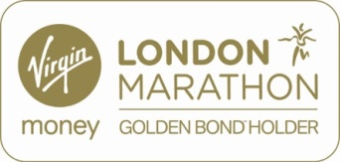
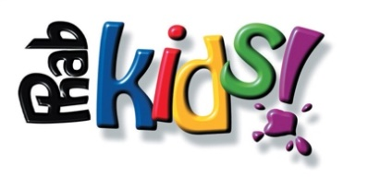

On-line Fundraising for Runners 2021

- Create your on-line sponsorship page by visiting JustGiving
http://www.justgiving.com/phab/raisemoney
Then follow the simple instructions to create and personalise your page.

- Or: Virgin Money Giving - http://uk.virginmoneygiving.com/charities/phab
It is important to choose your event and date of the event.

- Once you have created your page, email your page details to family, friends, colleagues, and other contacts for them to donate quickly and easily on-line with a credit or debit card.

- On-line donations from UK taxpayers will automatically benefit from the bonus of Gift Aid (currently 25%).

- The Gift Aid payment CANNOT be considered as part of your minimum pledge amount.

- Funds raised via JustGiving and Virgin Money Giving come directly through to Phab and we are updated weekly on your level of on-line sponsorship.

- Off-line funds should be sent to Phab (see FAQs) as they are received; please add these funds to your on-line JustGiving or Virgin Money Giving page.

FAQs

Virtual - Virgin Money London Marathon 2021, Sunday 3rd October 2021

Who should cheques be made payable to?
Phab Ltd

Do Phab require sponsors, not using an online site, to put their name, address, and postcode on the sponsor form for Gift Aid to be claimed?
YES – without the sponsors’ name, house number and postcode we are unable to claim the Gift Aid.

How do I fundraise?
Each individual has access to different fundraising sources and should fundraise in ways they feel comfortable with. For further tips please visit our web site http://www.phabkids.co.uk/ - there are lots of downloads at https://www.phabkids.co.uk/advice/fundraising

Can my sponsors pay by credit card or debit card?
YES – you can build your own web page with JustGiving or Virgin Money Giving for online sponsorship via credit or debit cards

If I raise some or all my sponsorship via JustGiving or Virgin Money Giving, is the Gift Aid recoverable considered part of the minimum pledge?
NO. Gift Aid cannot be included as part of your raised minimum pledge amount.

Do Phab supply running vests?
YES – you will be sent a Phabkids vest in your runner’s pack later in the year

If I sustain an injury prior to the race and have to withdraw am I committed to still send the minimum amount pledged?
No – your commitment to raise your pledged amount comes into effect once you run on race day.

If I start the marathon but do not finish am I still expected to honour the pledge?
Yes – Phab cannot claim back the place from the organisers for the following year if you actually start the run on race day.

When do Phab require the off-line sponsorship money by?
All Off-line money must be sent into us by cheque or by BACS as you raise this, with the balance of any off line money by the 3rd January 2022.

When, where and how do I register?

Phab will send you a link to register with London Marathon Events

Can Phab loan me a banner for fundraising?
YES – however we have a great need for these, and they must be returned afterwards

Can Phab supply collection boxes?
YES – Collection boxes are available, on request, but they MUST be returned empty after the event to Janine Williams, Phab Challenge Events Manager, 1 Calvert Road, West Park, Uckfield, East Sussex TN22 2DB. They are for use on private premises only and may not be used for street collection.

Can Phab supply me with a letter of authority?
YES - If any of your sponsors need a letter to prove to them that you are indeed running and raising money for Phab please get in touch with Janine.

Is it OK to put sponsors logos on my vest/T-shirt?
YES

Should I put my name on my vest/T-shirt?
YES DEFINITELY – This will get you round on the day with people calling your name

Can I give my place to someone else if I am unable to run?
NO – This is not allowed. If you are unable to run Janine Williams must be informed.
janine@phabkids.co.uk or phone 01825 749826

February 2021 for Virtual VMLM 2021

